**SUPPLEMENTARY MATERIAL FOR:** “Nitrogen demand, supply, and acquisition strategy control plant responses to elevated CO2”

**Results (cont.)**

*Leaf nitrogen content*

Elevated CO2 reduced *N*mass by 50% and increased *M*area by 44% (*p*<0.001 in both cases; Table SX). Increasing nitrogen fertilization increased *N*mass and *M*area more strongly under ambient CO2 than elevated CO2 (CO2-by-nitrogen fertilization interaction: *p*<0.001 in both cases), resulting in a stronger reduction in *N*mass and a stronger increase in *M*area under elevated CO2 with increasing nitrogen fertilization than ambient CO2 (Fig. S1). Increasing nitrogen fertilization increased *N*mass and *M*area more strongly in uninoculated plants compared to inoculated plants (inoculation-by-nitrogen fertilization interaction: *p*<0.05 in all cases; Table 1).

*The ratio of total biomass to pot volume*

Total biomass: pot volume increased with elevated CO2, inoculation, and nitrogen fertilization (*p*<0.001 in all cases; Table S6). Increasing nitrogen fertilization increased biomass: pot volume more strongly in uninoculated plants compared to inoculated plants (inoculation-by-nitrogen fertilization interaction: *p*<0.05; Table S6). Increasing nitrogen fertilization also increased biomass: pot volume more strongly under elevated CO2 as compared to ambient CO2 (CO2-by-nitrogen fertilization interaction: *p*<0.001; Fig. S6).

**Table S1** Summary table containing volumes of compounds used to create modified Hoagland’s solutions for each soil nitrogen fertilization treatment. All volumes are expressed as milliliters per liter (mL/L)

|  |  |  |  |  |  |
| --- | --- | --- | --- | --- | --- |
| **Compound** | **0 ppm N**  **(0 mM N)** | **35 ppm N**  **(2.5 mM N)** | **70 ppm N**  **(5 mM N)** | **105 ppm N**  **(7.5 mM N)** | **140 ppm N**  **(10 mM N)** |
| **1 M NH4H2PO4** | 0 | 0.165 | 0.33 | 0.5 | 0.67 |
| **2 M KNO3** | 0 | 0.335 | 0.67 | 1 | 1.33 |
| **2 M Ca(NO3)2** | 0 | 0.335 | 0.67 | 1 | 1.33 |
| **1 M NH4NO3** | 0 | 0.165 | 0.33 | 0.5 | 0.67 |
| **8 M NH4NO3** | 0 | 0 | 0 | 0 | 0 |
| **1 M KH2PO4** | 1 | 0.85 | 0.67 | 0.5 | 0.33 |
| **1 M KCl** | 3 | 2.45 | 2 | 1.5 | 1 |
| **1 M CaCO3** | 4 | 3.33 | 2.67 | 2 | 1.33 |
| **2 M MgSO4** | 1 | 1 | 1 | 1 | 1 |
| **10% Fe-EDTA** | 1 | 1 | 1 | 1 | 1 |
| **Trace elements** | 1 | 1 | 1 | 1 | 1 |
|  |  |  |  |  |  |
| **Compound** | **210 ppm N**  **(15 mM N)** | **280 ppm N**  **(20 mM N)** | **350 ppm N**  **(25 mM N)** | **630 ppm N**  **(45 mM N)** |  |
| **1 M NH4H2PO4** | 1 | 1 | 1 | 1 |  |
| **2 M KNO3** | 2 | 2 | 2 | 2 |  |
| **2 M Ca(NO3)2** | 2 | 2 | 2 | 2 |  |
| **1 M NH4NO3** | 1 | 3.5 | 0 | 0 |  |
| **8 M NH4NO3** | 0 | 0 | 0.75 | 2 |  |
| **1 M KH2PO4** | 0 | 0 | 0 | 0 |  |
| **1 M KCl** | 0 | 0 | 0 | 0 |  |
| **1 M CaCO3** | 0 | 0 | 0 | 0 |  |
| **2 M MgSO4** | 1 | 1 | 1 | 1 |  |
| **10% Fe-EDTA** | 1 | 1 | 1 | 1 |  |
| **Trace elements** | 1 | 1 | 1 | 1 |  |

**Table S2** Summary of the daily growth chamber growing condition program

|  |  |  |
| --- | --- | --- |
| **Time** | **Air temperature (ºC)** | **PAR ± SD (μmol m-2 s-1)** |
| 09:00 | 21 | 278±2 |
| 09:45 | 557±4 |
| 10:30 | 25 | 797±4 |
| 11:15 | 1230±12 |
| 22:45 | 21 | 797±4 |
| 23:30 | 557±4 |
| 00:15 | 17 | 278±2 |
| 01:00 | 0±0 |

**Table S3** Effects of CO2 concentration, inoculation, and nitrogen fertilization on leaf nitrogen content and leaf mass per area*

|  |  |  |  |  |  |
| --- | --- | --- | --- | --- | --- |
|  |  | ***N*mass** | | ***M*areaa** | |
|  | df | *χ*2 | *p* | *χ*2 | *p* |
| CO2 | 1 | 272.362 | **<0.001** | 151.319 | **<0.001** |
| Inoculation (I) | 1 | 15.576 | **<0.001** | 19.158 | **<0.001** |
| N fertilization (N) | 1 | 106.659 | **<0.001** | 21.440 | **<0.001** |
| CO2 × I | 1 | 2.025 | 0.155 | 0.029 | 0.866 |
| CO2 × N | 1 | 22.542 | **<0.001** | 7.619 | **0.006** |
| I × N | 1 | 11.137 | **0.001** | 5.022 | **0.025** |
| CO2 × I × N | 1 | 0.041 | 0.839 | 0.208 | 0.649 |

*Significance determined using Type II Wald χ2 tests (α=0.05). *P*-values less than 0.05 are in bold. A superscript “a” is included after trait labels to indicate if models were fit with natural log-transformed response variables. Key: df=degrees of freedom, *χ*2=Wald chi-square test statistic, *N*mass=leaf nitrogen content (gN g-1), *M*area=leaf mass per unit leaf area (g m-2).

**Table S4** Effects of CO2 concentration, inoculation, and nitrogen fertilization on photosynthetic nitrogen-use efficiency *

|  |  |  |  |  |  |
| --- | --- | --- | --- | --- | --- |
|  |  | ***PNUE*growth** | |  | |
|  | df | *χ*2 | *p* |  |  |
| CO2 | 1 | 300.197 | **<0.001** |  |  |
| Inoculation (I) | 1 | 9.897 | **0.002** |  |  |
| N fertilization (N) | 1 | 29.695 | **<0.001** |  |  |
| CO2 × I | 1 | 0.944 | 0.331 |  |  |
| CO2 × N | 1 | 5.359 | **0.021** |  |  |
| I × N | 1 | 10.883 | **<0.001** |  |  |
| CO2 × I × N | 1 | 0.369 | 0.544 |  |  |

*Significance determined using Type II Wald χ2 tests (α=0.05). *P*-values less than 0.05 are in bold. Key: df=degrees of freedom, *χ*2=Wald chi-square test statistic, *PNUE*growth=photosynthetic nitrogen-use efficiency (μmol CO2 gN-1 s-1),*χ*=isotope-based ratio of intercellular CO2 to extracellular CO2, inversely related to water-use efficiency (unitless)

**Table S4** Effects of CO2 concentration, inoculation, and nitrogen fertilization on components of the carbon cost to acquire nitrogen*

|  |  |  |  |  |  |
| --- | --- | --- | --- | --- | --- |
|  |  | ***C*bga** | | ***N*wpb** | |
|  | df | *χ*2 | *p* | *χ*2 | *p* |
| CO2 | 1 | 84.134 | **<0.001** | 23.890 | **<0.001** |
| Inoculation (I) | 1 | 41.030 | **<0.001** | 134.460 | **<0.001** |
| N fertilization (N) | 1 | 152.248 | **<0.001** | 529.021 | **<0.001** |
| CO2 × I | 1 | 8.965 | **0.003** | 1.190 | 0.275 |
| CO2 × N | 1 | 1.188 | 0.276 | 5.915 | **0.015** |
| I × N | 1 | 22.648 | **<0.001** | 55.562 | **<0.001** |
| CO2 × I × N | 1 | 1.109 | 0.292 | 0.620 | 0.431 |

*Significance determined using Type II Wald χ2 tests (α=0.05). A superscript “a” is included after trait labels to indicate if models were fit with natural-log transformed response variables, while a superscript “b” is included if models were fit with square-root transformed response variables. *P*-values less than 0.05 are in bold. Key: df=degrees of freedom, *C*bg=belowground carbon biomass (gC, numerator of *N*cost), *N*wp=total nitrogen biomass (gN, denominator of *N*cost).

**Table S5** Effects of CO2 concentration, inoculation, and nitrogen fertilization on investment toward symbiotic nitrogen fixation*

|  |  |  |  |  |  |  |  |
| --- | --- | --- | --- | --- | --- | --- | --- |
|  |  | **Root nodule biomassb** | | **Root**  **biomassb** | | **Root nodule: root biomassb** | |
|  | df | *χ*2 | *p* | *χ*2 | *p* | *χ*2 | *p* |
| CO2 | 1 | 19.258 | **<0.001** | 93.249 | **<0.001** | 0.010 | 0.921 |
| Inoculation (I) | 1 | 755.02 | **<0.001** | 6.983 | **0.008** | 902.063 | **<0.001** |
| N fertilization (N) | 1 | 84.376 | **<0.001** | 195.843 | **<0.001** | 254.741 | **<0.001** |
| CO2 × I | 1 | 0.950 | 0.330 | 3.873 | **0.049** | 21.632 | **<0.001** |
| CO2 × N | 1 | 2.106 | 0.147 | 11.456 | **<0.001** | 1.590 | 0.207 |
| I × N | 1 | 44.622 | **<0.001** | 7.435 | **0.006** | 132.463 | **<0.001** |
| CO2 × I × N | 1 | 0.196 | 0.658 | 0.065 | 0.799 | 2.481 | 0.115 |

*Significance determined using Type II Wald χ2 tests (α=0.05). A superscript “a” is included after trait labels to indicate if models were fit with natural log-transformed response variables, while a superscript “b” is included if models were fit with square-root transformed response variables. *P*-values less than 0.05 are in bold. Key: df=degrees of freedom, root nodule biomass (g), root biomass (g), root nodule: root biomass (unitless).

**Table S6** Effects of CO2 concentration, inoculation, and nitrogen fertilization on the ratio of total biomass to pot volume (g L-1)*

|  |  |  |  |
| --- | --- | --- | --- |
|  | df | *χ*2 | *p* |
| CO2 | 1 | 146.004 | **<0.001** |
| Inoculation (I) | 1 | 19.320 | **<0.001** |
| N fertilization (N) | 1 | 279.388 | **<0.001** |
| CO2 × I | 1 | 0.007 | 0.934 |
| CO2 × N | 1 | 49.725 | **<0.001** |
| I × N | 1 | 9.007 | **0.003** |
| CO2 × I × N | 1 | 0.640 | 0.434 |

*Significance determined using Type II Wald χ2 tests (α=0.05). *P*-values less than 0.05 are in bold. Key: df=degrees of freedom, *χ*2=Wald chi-square test statistic

**Figure S1**

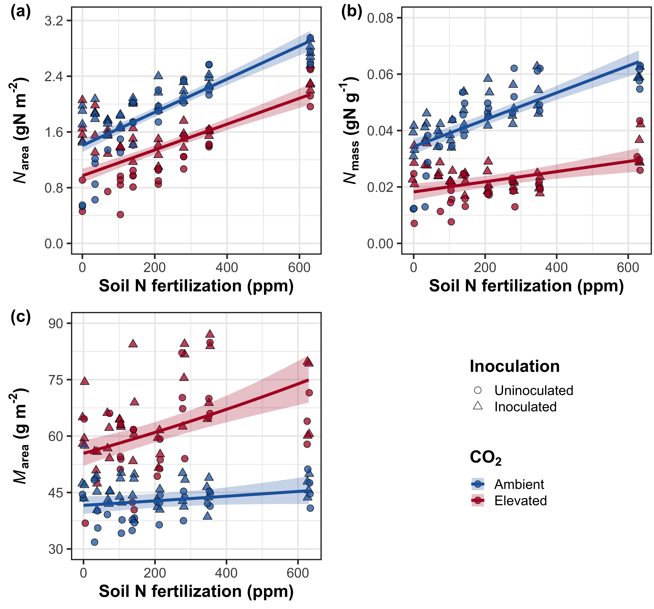

**Figure S1** Effects of CO2 and fertilization inoculation on area-based leaf nitrogen content (a), mass-based leaf nitrogen content (b), and leaf biomass per unit leaf area (c). Fertilization is represented on the x-axis. Red shaded points and trendlines indicate plants grown under elevated CO2, while blue shaded points and trendlines indicate plants grown under ambient CO2. Light blue and red circular points and trendlines indicate measurements collected from uninoculated plants, while dark blue and red triangular points indicate measurements collected from inoculated plants. Solid trendlines indicate regression slopes that are different from zero (*p*<0.05), while dashed trendlines indicate slopes that are not distinguishable from zero (*p*>0.05).

**Figure S2**

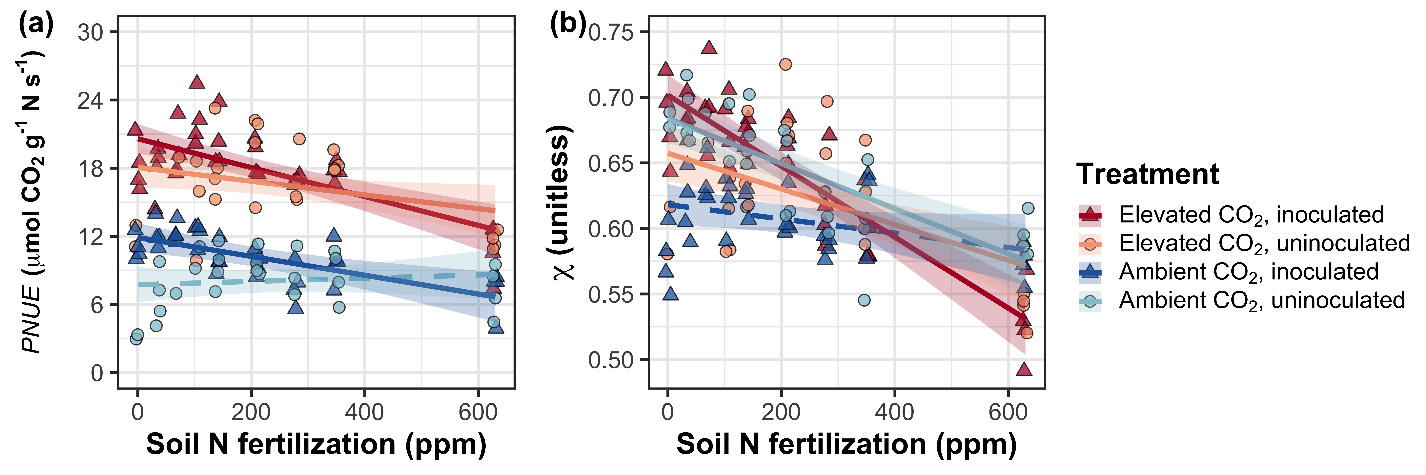

**Figure S2** Effects of nitrogen fertilization, inoculation treatment, and CO2 treatment on photosynthetic nitrogen-use efficiency (a) and *χ* (b). Fertilization is represented on the x-axis. Red shaded points and trendlines indicate plants grown under eCO2, while blue shaded points and trendlines indicate plants grown under aCO2. Light blue and red circular points and trendlines indicate measurements collected from uninoculated plants, while dark blue and red triangular points indicate measurements collected from inoculated plants. Solid trendlines indicate regression slopes that are different from zero (*p*<0.05), while dashed trendlines indicate slopes that are not distinguishable from zero (*p*>0.05).

**Figure S3**

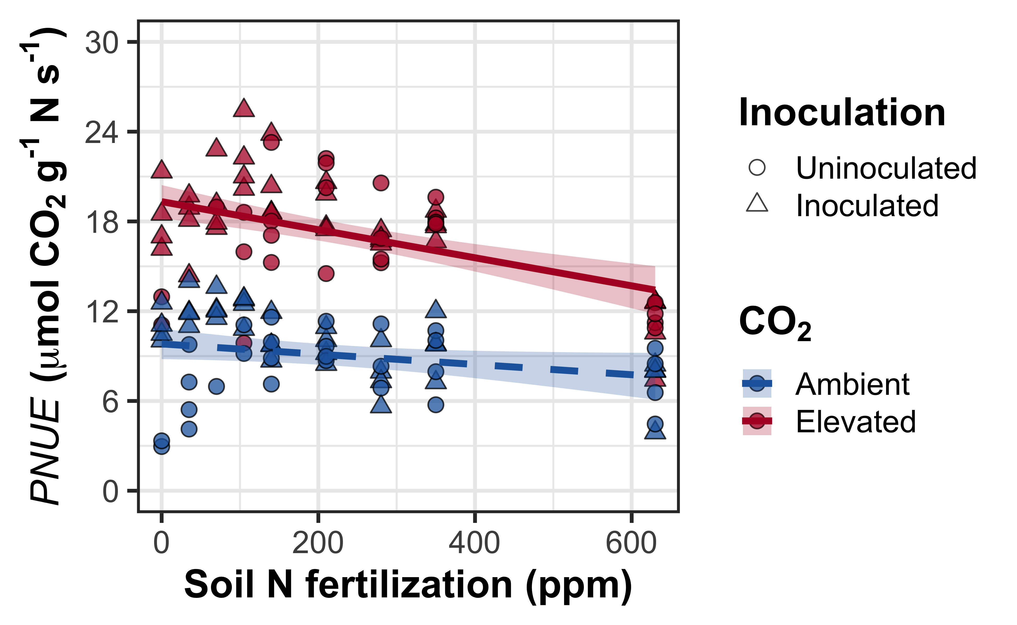

**Figure S3** Effects of CO2 and fertilization inoculation on photosynthetic nitrogen-use efficiency. Fertilization is represented on the x-axis. Red shaded points and trendlines indicate plants grown under eCO2, while blue shaded points and trendlines indicate plants grown under aCO2. Light blue and red circular points and trendlines indicate measurements collected from uninoculated plants, while dark blue and red triangular points indicate measurements collected from inoculated plants. Solid trendlines indicate regression slopes that are different from zero (*p*<0.05), while dashed trendlines indicate slopes that are not distinguishable from zero (*p*>0.05).

**Figure S4**

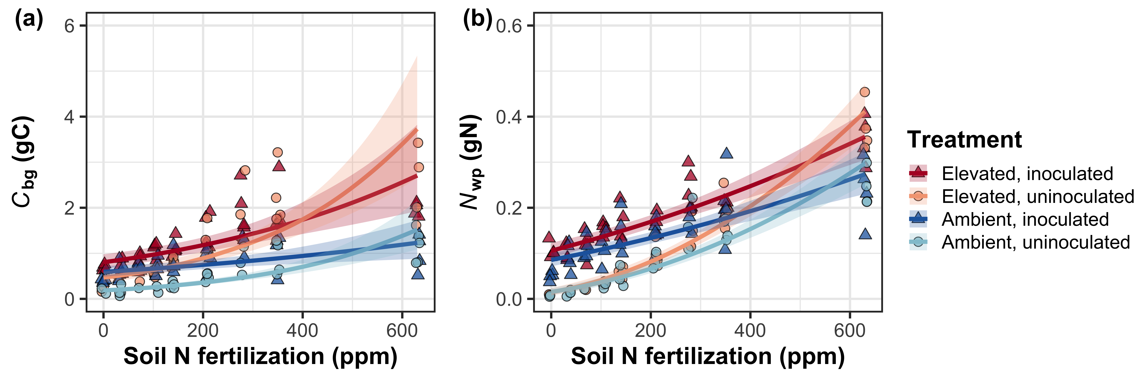

**Figure S4** Effects of CO2 and fertilization inoculation on belowground carbon biomass (a) and total nitrogen biomass (b). Belowground carbon biomass is the numerator of *N*cost, while total nitrogen biomass is the denominator of *N*cost. Fertilization is represented on the x-axis in all panels. Red shaded points and trendlines indicate plants grown under eCO2, while blue shaded points and trendlines indicate plants grown under aCO2. Light blue and red circular points and trendlines indicate measurements collected from uninoculated plants, while dark blue and red triangular points indicate measurements collected from inoculated plants. Solid trendlines indicate regression slopes that are different from zero (*p*<0.05), while dashed trendlines indicate slopes that are not distinguishable from zero (*p*>0.05).

**Figure S5**

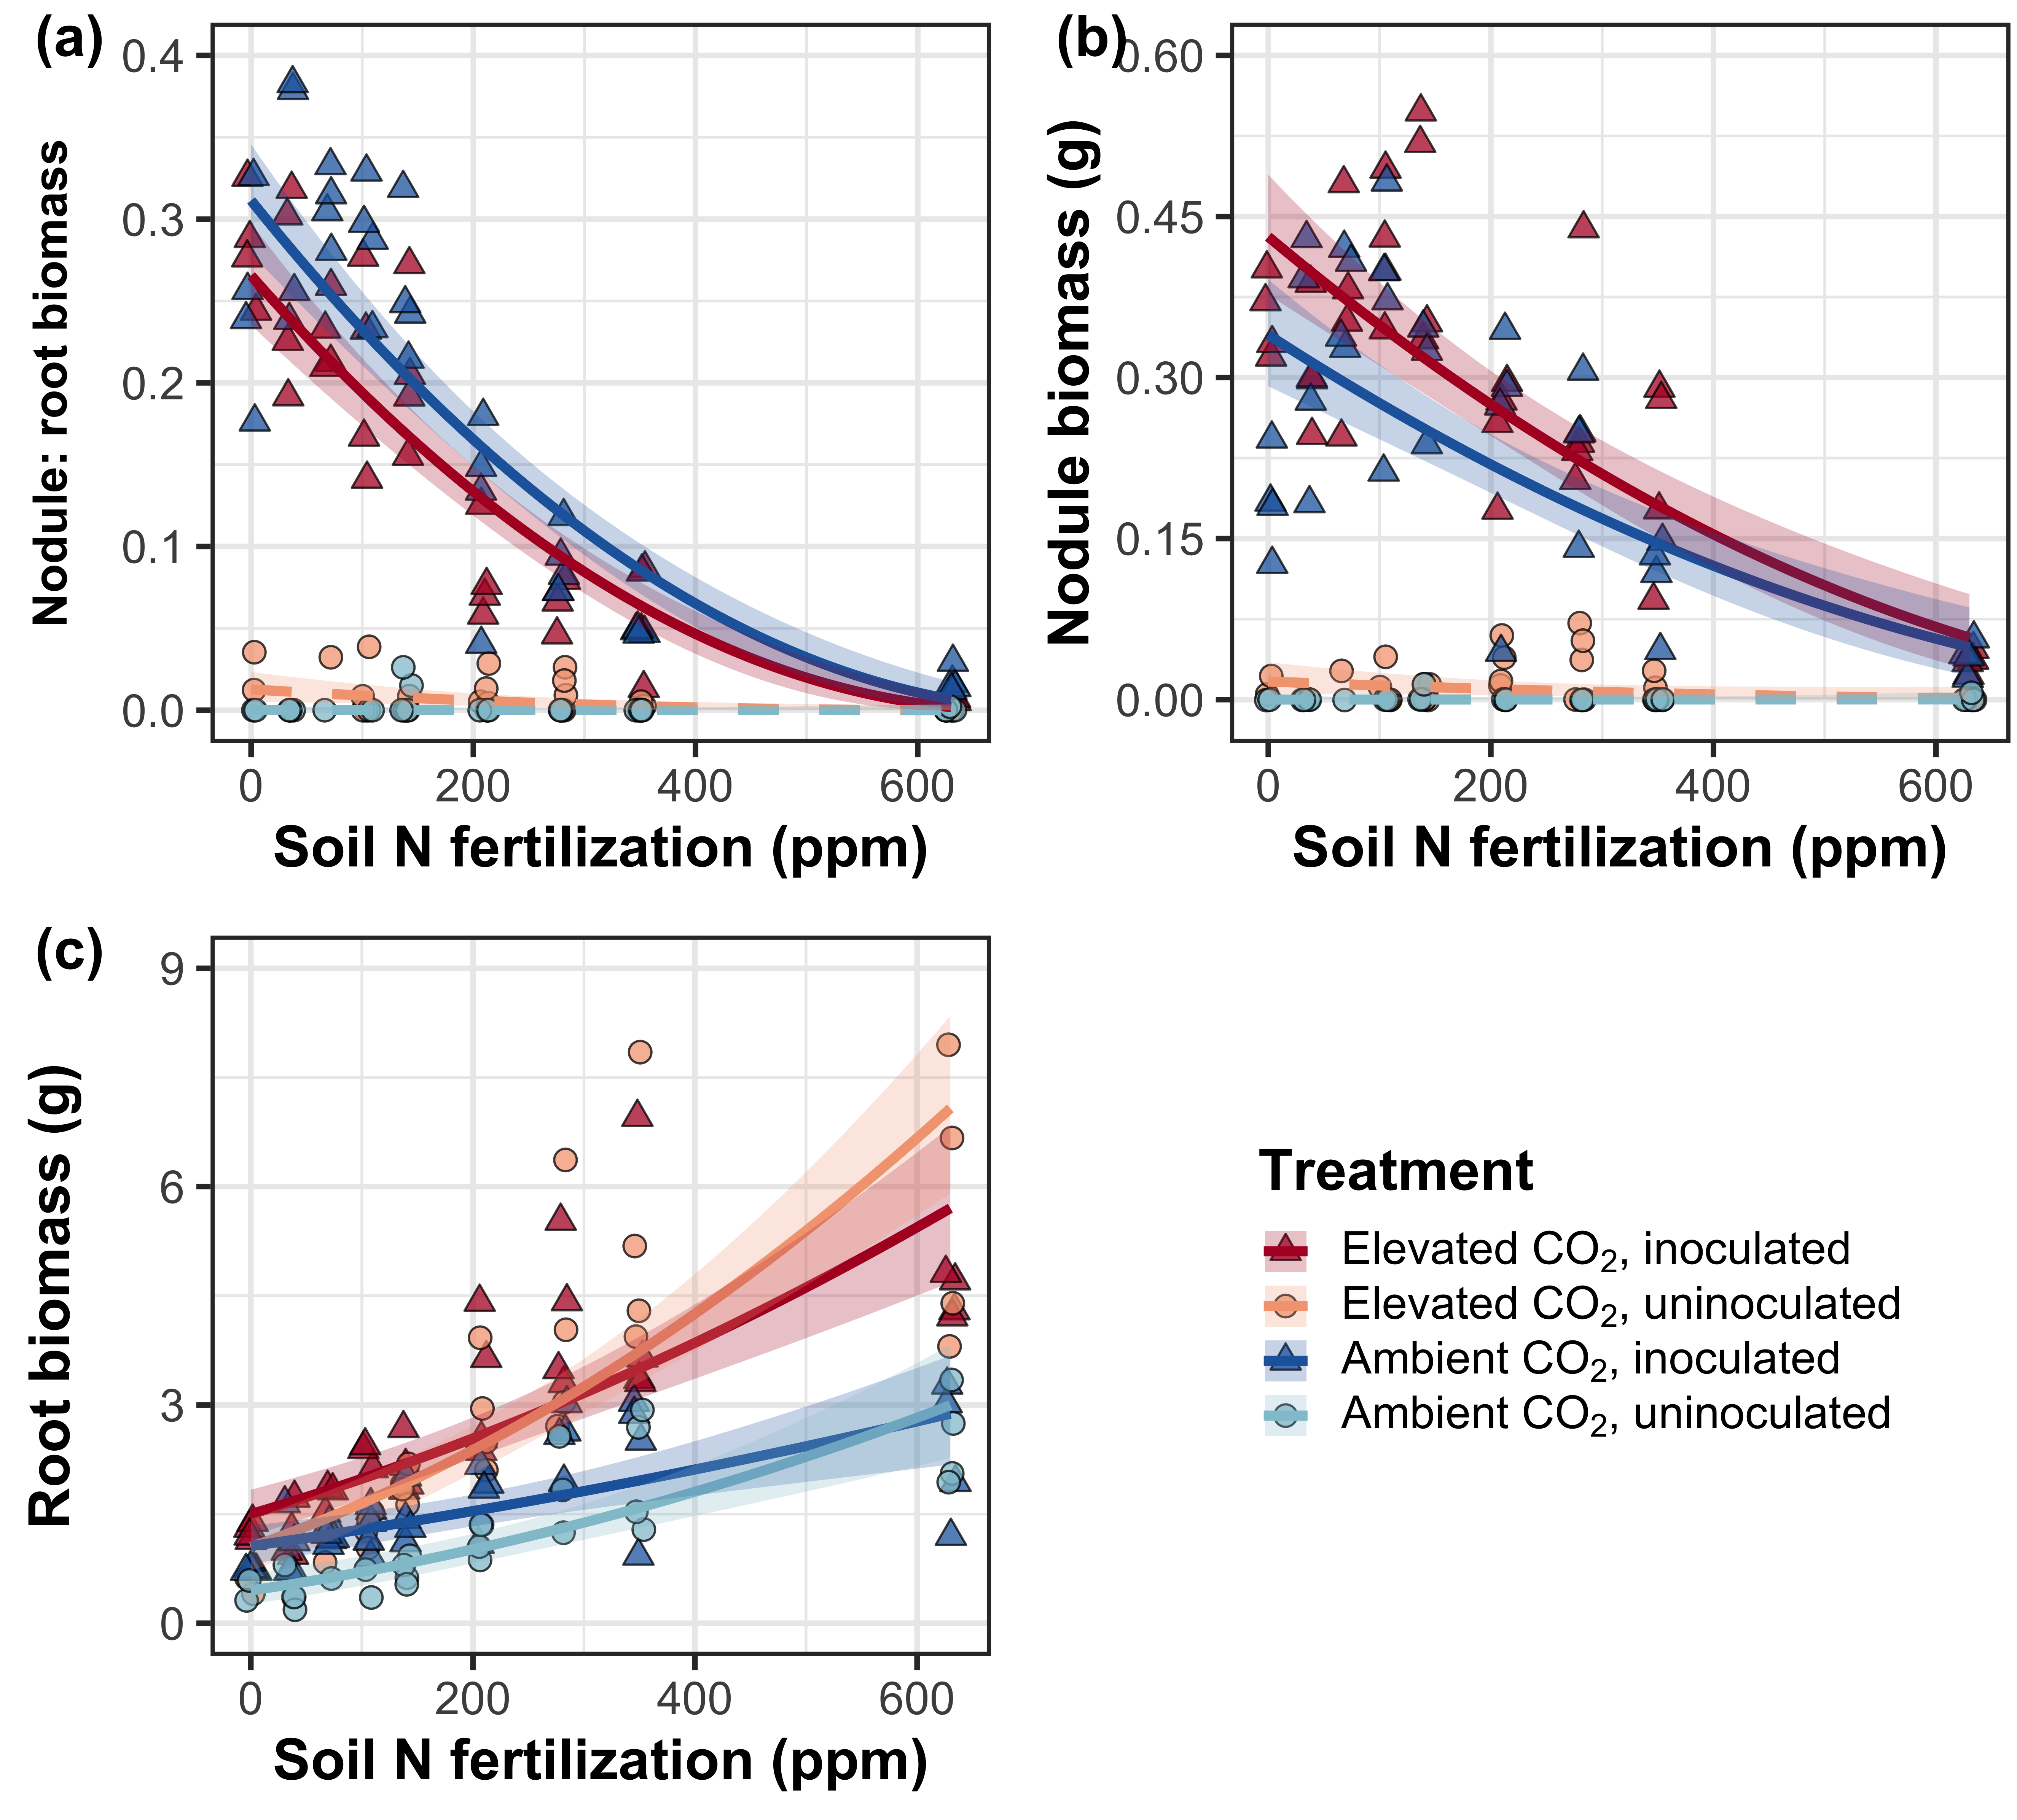

**Figure S5** Effects of nitrogen fertilization, inoculation treatment, and CO2 treatment on root nodule biomass: root biomass (a), root nodule biomass (b), and root biomass (c). Nitrogen fertilization is represented on the x-axis. Red shaded points and trendlines indicate plants grown under eCO2, while blue shaded points and trendlines indicate plants grown under aCO2. Light blue and red circular points and trendlines indicate measurements collected from uninoculated plants, while dark blue and red triangular points indicate measurements collected from inoculated plants. Solid trendlines indicate regression slopes that are different from zero (*p*<0.05), while dashed trendlines indicate slopes that are not distinguishable from zero (*p*>0.05).

**Figure S6**

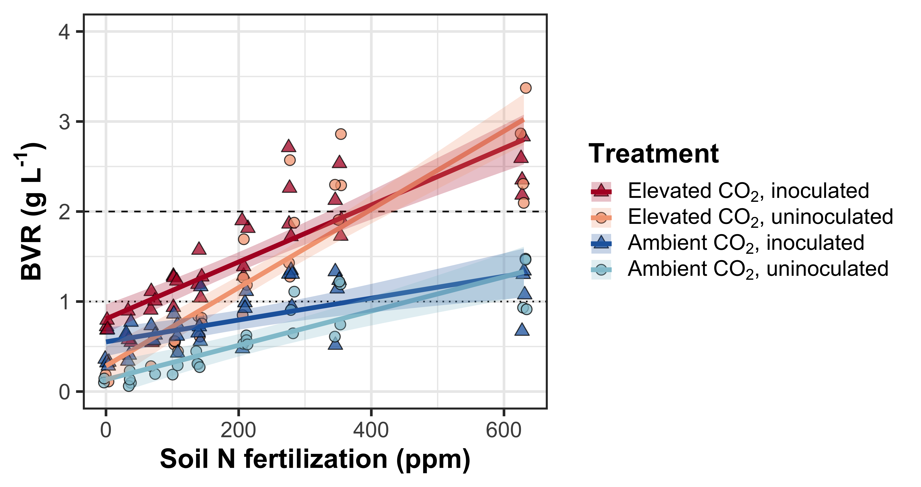

**Figure S6** Effects of CO2, fertilization, and inoculation on the ratio of whole plant biomass to pot volume. Fertilization is represented on the x-axis. Red shaded points and trendlines indicate plants grown under eCO2, while blue shaded points and trendlines indicate plants grown under aCO2. Light blue and red circular points and trendlines indicate measurements collected from uninoculated plants, while dark blue and red triangular points indicate measurements collected from inoculated plants. Solid trendlines indicate regression slopes that are different from zero (*p*<0.05). The dotted horizontal line indicates the point where biomass: pot volume exceeds 1 g L-1, and the dashed line indicates the point where biomass: pot volume exceeds 2 g L-1.